**Exercise – 8**

1. **Search Filter**

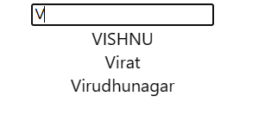

1. **Image Slider**

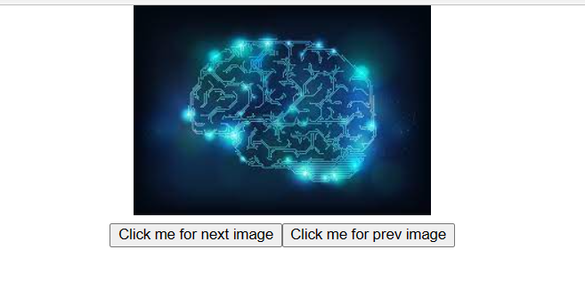



**Exercise – 9**

1. **Stack using generic type**

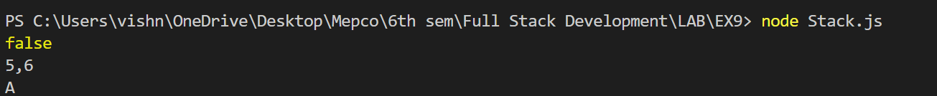

1. **Salary Calculation of Employee**

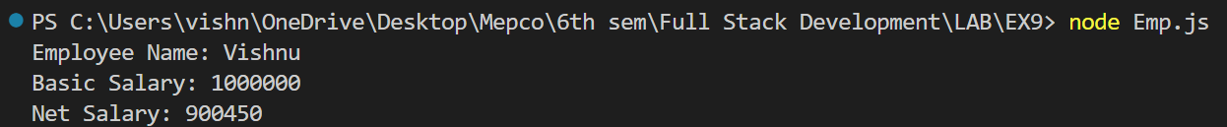

1. **Sort based on Author name**

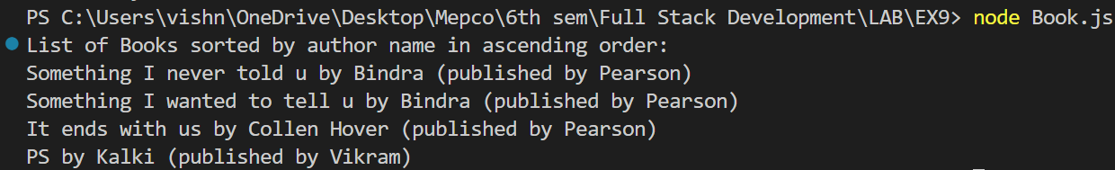

**Exercise – 10**

1. **Filter books based on the year and author**

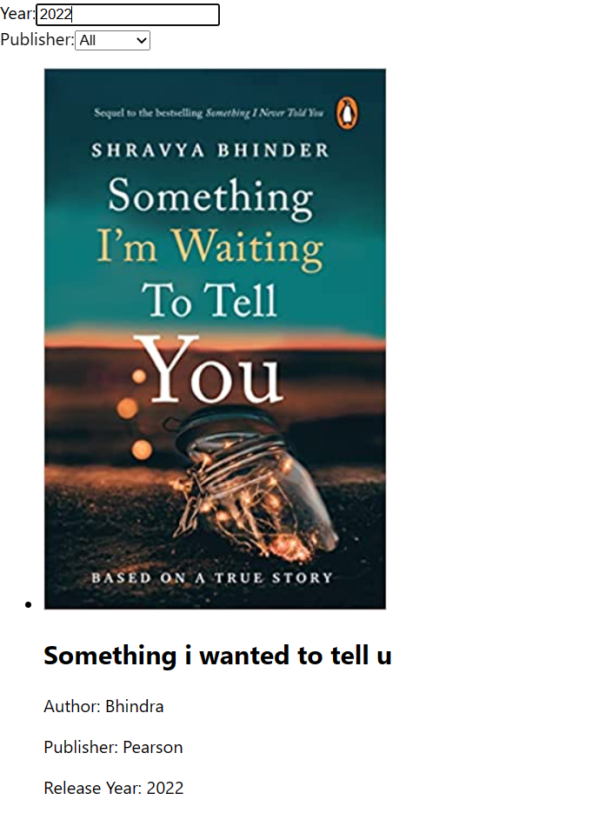

1. **Counter**

